WEB BASED INTERGRATED COMPLIANCE TRACKING AND RISK
MANAGEMENT SYSTEM FOR FACILITY SAFETY

Tarimo, Graciana Faustin

BSc (Information Systems Management) Dissertation

Ardhi University
August 2026

WEB BASED INTERGRATED COMPLIANCE TRACKING AND RISK
MANAGEMENT SYSTEM FOR FACILITY SAFETY

By
Tarimo, Graciana Faustin

A Dissertation Submitted in fulfillment of the requirements for the degree of Bachelor of Science Information system management of Ardhi University

Ardhi University
July 2026

DECLARATION
I, Tarimo, Graciana Faustin (30565/T.2023), Hereby declare that this report is my own work and effort, the matter embodied in this dissertation has not been submitted to, and will not be submitted to, any other university to receive a similar or different degree. The work in this report was carried out in accordance with the Regulations of the Ardhi University.
I have faithfully acknowledged, given credit to, and referred to the research workers wherever their work has been cited in the text and the body of the dissertation. I further certify that I have not willfully lifted some other’s paragraph, text, data, result e.t.c. reported in the journals, books, magazines, reports, dissertations, thesis e.t.c. or available at web-sites and included them in this dissertation and cited them as my work.

Student’s Name | Signature |  | Date
Tarimo, Graciana Faustin | ……………………. |  | …………………..

The Berne Convention, the Copyright Act of 1999, and other international and national laws on intellectual property protect this dissertation’s copyrighted content. It may not be reproduced by any means, in full or in part, except for short extracts in fair dealings, for research or private study, critical scholarly review, or discourse with an acknowledgment, without the written permission of the Directorate of undergraduate Studies, on behalf of both the authors and Ardhi University.

CERTIFICATION
The undersigned certify that they have read and hereby recommend for acceptance by Ardhi University a dissertation titled: integrated compliance tracking and risk
management system for facility safety, in fulfillment of the requirements for the degree of Bachelor of Science Information system management of Ardhi University.

………………………………
Mr. Saidi Kamali

Date: ……………….

……………………………….
Mr. Ibrahim Ryoba

Date: ……………….

ACKNOWLEDGEMENT

First and foremost, I would like to express my sincere gratitude to the Almighty God for granting me the strength, wisdom, and perseverance throughout the development of this project. His guidance has been a constant source of inspiration, enabling me to overcome challenges and successfully complete the web based Integrated Compliance Tracking and Risk Management System for Facility Safety.
I would also like to extend my heartfelt appreciation to my supervisors, Mr. Kamali Said and Mr. Ibrahim Ryoba, for their continuous support, guidance, and constructive feedback throughout this study. Their expertise and encouragement played a significant role in shaping the direction and quality of this project. I am also grateful to my lecturers and colleagues for their valuable contributions, ideas, and support during the development process.
Hence, I wish to thank my family, friends, and the Higher Education Students’ Loans Board (HESLB) for their encouragement and support throughout my academic journey. I, Tarimo ,Graciana Faustin, sincerely acknowledge all individuals and organizations whose assistance contributed to the successful completion of this project.

LIST OF ABBREVIATIONS

ARU Ardhi University
OS Operating Systems
UML Unified Modeling Language
ERD Entity Relationship Diagram
HESLB Higher Education Students’ Loans Board

ABSTRACT
This project presents the design and development of a web based Integrated Compliance Tracking and Risk Management System for Facility Safety. The system aims to address challenges associated with manual and fragmented approaches to monitoring facility compliance, inspection schedules, and risk management. Many organizations lack centralized systems to track statutory inspections, certification expiry, and asset-based risks, which may lead to non-compliance, safety incidents, and inefficient operations. The proposed system provides a digital solution to enhance proactive monitoring and decision-making in facility safety management.
The system was developed using a web-based architecture that integrates key modules such as asset management, inspection scheduling, compliance tracking, risk assessment, incident reporting, and corrective and preventive action (CAPA) management. Data was collected through Observation, Interview, literature review and analysis of existing facility management practices. Modern technologies including React, Node.js, and PostgreSQL were used to design and implement the system. The system automates inspection reminders, tracks compliance status, maintains risk registers, and generates alerts for expiring certifications and unresolved issues.
The outcome of this project is a centralized platform that improves visibility, accountability, and efficiency in managing facility safety and regulatory compliance. The system supports timely decision-making, reduces the risk of non-compliance, and enhances overall safety performance. It is expected to benefit organizations by providing a structured and reliable approach to facility compliance and risk management.
TABLE OF CONTENTS
DECLARATION i
CERTIFICATION ii
ACKNOWLEDGEMENT iii
LIST OF ABBREVIATIONS iv
ABSTRACT v
LIST OF FIGURES ix
LIST OF TABLES x
CHAPTER ONE 1
INTRODUCTION 1
1.1 General Introduction 1
1.2 Statement of the Problem 1
1.3 Objectives 2
1.3.1 General Objective 2
1.3.2 Specific objective 2
1.4 Research Questions 2
1.5 Significance of the Study 2
1.6 Structure of the report 3
CHAPTER TWO 4
LITERATURE REVIEW 4
2.1 Introduction 4
2.2 Related Studies 4
2.3 Research Gap 7
CHAPTER THREE 1
METHODOLOGY 1
3.1 Introduction 1
3.2 Selected Methodology 1
3.2.1 Methodology for Gathering User Requirement 1
3.2.2 Methodology for System design 2
3.2.3 Methodology for System implementation 2
3.2.4 Methodology for System testing and Validation 3
3.3 Methodology table 4
CHAPTER FOUR 5
SYSTEM ANALYSIS AND DESIGN 5
4.1 Introduction 5
4.2 Requirement Analysis 5
4.2.1 System Requirement 5
4.2.1.1 Software Requirement 6
3.2.1 User Requirement 8
4.2.2.1 Functional Requirement 8
4.3 System Design 1
4.3.1 System Architecture 1
4.3.2 Entity Relationship Diagram (ERD) 3
CHAPTER FIVE 5
IMPLEMENTATION AND TESTING 5
5.1 Introduction 5
5.2 Implementation 5
5.2.1 User Authentication Interface 5
5.2.2 Dashboard Interface 6
5.2.3 Asset Management Interface 6
5.2.4 Inspection Management Interface 7
5.2.5 Compliance Tracking Interface 8
5.2.6 Risk Assessment Interface 9
5.2.7 Incident Management Interface 9
5.2.8 CAPA Management Interface 10
5.2.9 Notification Interface 10
5.2.10 Reports Interface 11
5.3 Testing 12
5.3.1 Unit Testing 12
5.3.2 Integration Testing 12
5.3.3 System Testing 13
5.3.4 Black-box Testing 13
5.3.5 Functional Testing 13
CHAPTER SIX 15
RESULTS AND DISCUSSION 15
6.1 Introduction 15
6.2 Findings 15
6.2.1 Product 16
6.3 Goal Achieved 17
6.4 Challenges and Limitations 17
CHAPTER SEVEN 19
CONCLUSION AND RECOMMENDATIONS 19
7.1 Introduction 19
7.2 Conclusion 19
7.2.1 Conclusion for Objective One 19
7.2.2 Conclusion for Objective Two 19
7.2.3 Conclusion for Objective Three 20
7.2.4 Conclusion for Objective Four 20
7.3 Recommendations 20
7.3 Recommendations 21
7.4 Further Study 21
REFERENCES 22
APPENDIX 24

LIST OF FIGURES
Figure 4.3 System architecture 2
Figure 4.2 ERD diagram 4
Figure 5.1: Login Page. 6
Figure 5.2: Dashboard Interface. 6
Figure 5.3: Asset Management Interface. 7
Figure 5.4: Inspection Management Interface. 8
Figure 5.5: Compliance 8
Figure 5.6: Risk Assessment Interface. 9
Figure 5.7: Incident Management Interface 10
Figure 5.8: CAPA Management Interface. 10
Figure 5.9: Notification Interface. 11
Figure 5.10: Reports Interface. 12

LIST OF TABLES
Table 2.1 Summary of literature reviews 10
Table 3.1 Methodology Table 4
Table 5.1: Functional Testing Results 13
Table: Summary of Interview Responses 24

CHAPTER ONE

INTRODUCTION

General Introduction
Safety and facilities compliance management is a significant aspect of organizations dealing with complex facilities such as fire protection systems, lifts, boilers, pressure vessels, and electrical equipment. Therefore, proper monitoring of such facilities is a prerequisite for the prevention of accidents and the maintenance of continuity in the facilities. These facilities and assets require regular inspections, maintenance, and monitoring to ensure that they remain safe, functional, and compliant with the required standards and regulations. Failure to properly manage these assets may result in equipment failure, safety incidents, operational interruptions, property damage, and increased risks to employees and other facility users.
However, traditional safety management is usually manual, disjointed, and paper-intensive, which may result in delayed reporting of hazards, missed inspections, and ineffective corrective actions. In many organizations, inspection records, risk information, maintenance documents, and certification records may be stored separately using paper files, notebooks, spreadsheets, or other manual methods. This can make it difficult for responsible personnel to access accurate information, monitor the status of facility assets, and identify upcoming inspection or certification dates. As a result, important inspections may be delayed, certificates may expire without timely action, and identified safety issues may not be properly followed up.
The proposed Integrated Compliance Tracking and Risk Management System for Facility Safety provides a unified solution to manage safety data, track asset risks, schedule inspections, and monitor compliance efficiently. The system is designed to support the management of different facility assets and their associated compliance requirements. It will enable users to record and monitor inspection activities, identify and assess hazards, maintain risk registers, report incidents and near-misses, and track corrective and preventive actions. The system can also support the management of certification information and provide notifications for upcoming inspections, overdue activities, and other important compliance requirements.

Statement of the Problem
In many organizations, facility safety and compliance management are still handled using manual, paper-based, or fragmented systems. These approaches make it difficult to maintain accurate records, track inspections, and manage safety-related activities efficiently. As a result, organizations often struggle to ensure that all facility assets such as fire systems, lifts, electrical installations, boilers, and pressure vessels meet required safety and regulatory standards.
However, the absence of a centralized and integrated system creates significant challenges in managing facility operations. Organizations face poor record keeping, missed statutory inspections, delayed hazard and incident reporting, and limited visibility of compliance status. In addition, there is no effective mechanism for real-time risk identification, monitoring of asset-based risks, or tracking of corrective and preventive actions, which increases the likelihood of safety incidents and regulatory non-compliance.
Therefore, this study proposes the development of a web based Integrated Compliance Tracking and Risk Management System for Facility Safety. The system will provide a centralized platform for managing compliance information, tracking inspections and certifications, supporting asset-based risk assessment, and monitoring corrective actions.

Objectives

General Objective
To develop an Integrated Compliance Tracking and Risk Management System for Facility Safety.

Specific objective
- To identify and gather user requirements for the web based Integrated Compliance Tracking and Risk Management System for Facility Safety.
- To design the web based Integrated Compliance Tracking and Risk Management System for Facility Safety.
- To implement the web based Integrated Compliance Tracking and Risk Management System for Facility Safety.
- To test and validate the Integrated Compliance Tracking and Risk Management System for Facility Safety.

Research Questions
- How can user requirements for the mobile-based Integrated Compliance Tracking and Risk Management System for Facility Safety be identified and gathered?
- How can the mobile-based Integrated Compliance Tracking and Risk Management System for Facility Safety be designed?
- How can the mobile-based Integrated Compliance Tracking and Risk Management System for Facility Safety be implemented?
- How can the mobile-based Integrated Compliance Tracking and Risk Management System for Facility Safety be tested and validated?

Significance of the Study
The Integrated Compliance Tracking and Risk Management System for Facility Safety is significant because it addresses critical gaps in current facility management practices, where safety compliance and risk tracking are often manual, fragmented, or paper-based. By centralizing facility data and automating monitoring processes, the system provides several key benefits:
- Enhanced Safety and Risk Management: The system enables real time hazard monitoring, asset-level risk tracking, and timely corrective and preventive actions (CAPA), reducing the accidents and improving overall safety within facilities.
- Regulatory Compliance: By tracking statutory inspections, certification expiries, the system ensures adherence to local and international safety standards, supporting organizations in avoiding penalties and legal issues.
- Operational Efficiency: Automating compliance monitoring and record keeping reduces manual workload, prevents delays in hazard reporting, and improves decision-making efficiency for facility managers.
- Accountability and Transparency: The platform provides a centralized repository of safety records, risk assessments, and corrective actions, enhancing accountability across departments and facilitating audit readiness.

Structure of the report
This report is organized into seven chapters, each addressing a specific aspect of the study. Chapter One presents the introduction, which includes the background of the study, problem statement, research objectives, and scope of the project. It provides the overall context and purpose of the study.
Chapter Two contains the literature review, which examines existing studies, technologies, and approaches related to facility compliance tracking and risk management. This chapter helps identify research gaps and justifies the need for the proposed system.
Chapter Three describes the research methodology used in this study. It explains the data collection methods, system development approach, and tools and techniques applied during the development process.
Chapter Four focuses on system analysis and design. It presents system requirements, system architecture, and user interfaces.
Chapter Five discusses system implementation and testing. It explains how the system was developed, integrated, and tested to ensure it meets the required functionality.
Chapter Six presents the results and discussion. It evaluates the performance of the system, analyzes outcomes, and discusses how the system addresses the identified problem.

CHAPTER TWO

LITERATURE REVIEW

Introduction
A literature review is a structured analysis of existing research and scholarly work related to a particular field of study. It helps to identify previous efforts, existing challenges, and knowledge gaps while providing a strong foundation for new projects(Sommerville, 2011). For this study, the literature review focuses on facilities compliance monitoring, facility risk tracking, and facilities records keeping.

Related Studies
Amer et al., (2015) examined electrical fire risks in substations and proposed a risk management framework emphasizing hazard identification, causes of electrical fires (e.g., insulation failure, arc flash, equipment overheating), and mitigation strategies, often referencing NFPA and IEEE standards. The study show that these risk evaluation practices support safety planning and decision making at facilities with high voltage equipment. However, limitations include absence of digital compliance tracking technologies such as sensor-based condition monitoring, automated alert systems, structured inspection scheduling tools, or integrated digital risk registers, indicating that the proposed framework remains largely conceptual and manual in execution.
Shaw et al., (2023) examined the application of digital technologies to improve building and facility safety. The study highlighted the use of Building Information Modelling (BIM), digital monitoring systems, and smart technologies to enhance safety visibility and real-time hazard identification. Findings showed that integrating digital models with real-time data improves risk awareness and supports informed decision-making in facility management. However, the study has limitations. It does not provide a structured framework for statutory compliance monitoring, inspection scheduling, certification tracking, or Corrective and Preventive Action (CAPA) workflows. Additionally, asset-based risk registers and automated compliance alerts were not addressed, revealing a gap in centralized compliance tracking and regulatory management.
Marchetti et al., (2026) examined integrated risk and safety management systems within engineering and industrial environments. The chapter emphasized unifying risk assessment, monitoring, and control processes into a comprehensive framework to enhance organizational safety. It highlighted structured risk assessment models, digital information systems, and safety documentation platforms to improve hazard identification, coordination, and decision making. The findings suggested that centralized integration strengthens transparency and risk mitigation effectiveness. However, the chapter is largely conceptual and lacks implementation detail. It does not provide mechanisms for real time hazard monitoring, asset-based inspection tracking, compliance scheduling, or automated corrective action workflows, revealing a gap between theoretical integration and practical facility level safety management.
Chu (2017) examined energy and water utility infrastructure management (WIM) systems, focusing on integrated monitoring technologies and control platforms to improve operational efficiency and reliability of facility utility services. The study shown that such monitoring enhances system visibility, supports timely maintenance decisions, and contributes to safer and more effective facility operations. However, limitations exist in compliance tracking and structured risk management. The research primarily addresses operational monitoring rather than statutory inspection compliance, certification expiry management, or regulatory governance. Additionally, it lacks an integrated asset-based risk register linking facility components to hazard ratings, as well as automated Corrective and Preventive Action (CAPA) workflows for addressing safety issues. While operational insights are provided, no centralized compliance tracking system or structured digital workflow for continuous facility safety assurance is established, indicating a gap in proactive regulatory and safety management
Barbosa et al., (2022) examined an Integrated Management System (IMS) to improve OH&S risk management in a medium-sized waste firm. The study shown that digital documentation and structured risk assessment reduced occupational accidents, increased worker engagement, and strengthened management support. However, limitations exist at the facility level, as the research does not cover assets like fire protections, electrical systems, boilers, or pressure vessels. It also lacks real-time compliance tracking, digital data consolidation, and automated CAPA workflows, indicating a gap between IMS theory and practical facility level hazard monitoring.
Salaheldin et al., (2021) examined a fire code compliance assessment tool for educational facilities, developing a structured worksheet based on international fire codes to assess fire prevention measures. The study shown that systematic evaluation of 34 prevention measures helps identify shortcomings such as inactive record keeping and design non conformities, supporting thorough inspections. However, limitations include lack of digital automation, real-time hazard detection, compliance alerting, risk scoring algorithms, and integration with digital asset monitoring. The research focuses on paper-based checklist methodology rather than technologies such as web inspection apps, sensor data, or automated dashboards, indicating a gap in proactive digital fire compliance (Marchetti-Mercer, 2012)
Shabani et al., (2024) provided a comprehensive review of safety audits and their role in ensuring workplace safety and compliance in Zimbabwe, synthesizing evidence from multiple databases on audit processes, components, benefits, and limitations. The study shown that safety audits systematically evaluate organizational safety management systems, policies, and practices to identify hazards and enable corrective actions that prevent accidents and occupational illnesses. However, limitations exist in digital automation and advanced technologies; the review focuses on traditional audit frameworks rather than technologies such as real time monitoring tools, sensor-based hazard detection, automated compliance alerts, or integrated digital risk registers, indicating a gap in modern, technology enabled compliance systems.
Ramos et al., (2011) examined environmental and safety compliance management systems within organizational settings, focusing on structured frameworks, internal auditing, and governance mechanisms to support regulatory adherence. The study shown that organizations applying systematic compliance monitoring demonstrate improved regulatory performance, reduced environmental violations, and enhanced accountability in safety management processes. However, limitations exist in facility level and digital compliance management. The research primarily addresses policy and administrative compliance rather than operational monitoring of assets such as fire protections, lifts, electrical installations, boilers, and pressure vessels. Additionally, it lacks real time hazard detection, automated compliance alerts, inspection scheduling models, and integrated asset-based risk registers. While corrective actions are conceptually discussed, no structured digital workflows for task assignment or deadline monitoring are provided, indicating a gap in proactive facility safety management.
The reviewed the integration of Industry 4.0 technologies (such as IoT sensors, cloud computing, big data analytics, artificial intelligence/machine learning, edge computing, blockchain, and Building Information Modelling) in fire and safety management to enhance hazard detection, monitoring, and response. The study shown that these technologies can enable real time data collection, predictive analytics, and situational awareness for fire risk reduction. However, limitations exist in proposing concrete frameworks for automated compliance alerts, structured asset-based risk registers, inspection scheduling models, and CAPA workflows, indicating that operational governance and regulatory tracking remain less developed than the core technological potential.
Shabani et al., (2024) provided a comprehensive review of safety audits and their role in ensuring workplace safety and compliance in Zimbabwe, synthesizing evidence from multiple databases on audit processes, components, benefits, and limitations. The study shown that safety audits systematically evaluate organizational safety management systems, policies, and practices to identify hazards and enable corrective actions that prevent accidents and occupational illnesses. However, limitations exist in digital automation and advanced technologies; the review focuses on traditional audit frameworks rather than technologies such as real time monitoring tools, sensor-based hazard detection, automated compliance alerts, or integrated digital risk registers, indicating a gap in modern, technology enabled compliance systems.

Research Gap
Despite advances in digital monitoring, integrated management systems, and compliance frameworks, several gaps remain in facility level safety and compliance management, as highlighted in the literature. This project aims to bridge these gaps by designing an Integrated Compliance Tracking and Risk Management System for Facility Safety that provides the following improvements:
- Absence of asset-based risk tracking: Current IMS or compliance systems do not track individual facility assets such as fire systems, lifts, boilers, or electrical installations. Our system creates dynamic risk registers for each asset, updating hazard levels continuously.
- No automated corrective and preventive action (CAPA) workflows: Literature shows CAPA processes are mostly manual or undefined. This system assigns, tracks, and escalates corrective actions automatically with deadlines and responsible persons.
- Lack of real time hazard monitoring: Existing frameworks are mostly not focused on real time hazard monitoring. The proposed system enables to identified risks before happen by alert the person or team responsible for maintenances.
- Limited statutory compliance monitoring: Existing studies do not integrate inspection scheduling, certification expiry alerts, or regulatory reporting. Our system centralizes all
- No automated corrective and preventive action (CAPA) workflows: Literature shows CAPA processes are mostly manual or undefined. This system assigns, tracks, and escalates corrective actions automatically with deadlines and responsible persons.

2.3 Summary of literature reviews
S/N | Author’s name& year | Technologies used
S/N | Author’s name& year | Compliance Framework | Manual Checklist | IoT / Smart Sensors | Web based system | Risk Register | Automated Alerts/ CAPA
1 | (Ramos et al., 2020) | ✗ | ✗ | ✓ | ✓ | ✗ | ✗
2 | (Chu et al., 2018) | ✗ | ✗ | ✓ | ✓ | ✗ | ✗
3 | (Abad et al., 2020) | ✓ | ✗ | ✗ | ✓ | ✗ | ✗
4 | (Salaheldin et al., 2021) | ✓ | ✓ | ✗ | ✗ | ✗ | ✗
5 | (Negi et al., 2024) | ✗ | ✗ | ✓ | ✓ | ✗ | ✗
6 | (Amer et al., 2022) | ✓ | ✓ | ✗ | ✗ | ✗ | ✗
7 | (Shabani et al., 2024) | ✓ | ✓ | ✗ | ✗ | ✗ | ✗
8 | (IEOM Study, 2022) | ✓ | ✗ | ✗ | ✗ | ✓ | ✗
 | (Abad et al., 2012) | ✓ | ✗ | ✗ | ✓ | ✗ | ✗
'10 | Tarimo (2026) | ✓ | ✗ | ✗ | ✓ | ✓ | ✓

CHAPTER THREE

METHODOLOGY

Introduction
This chapter presents the methodology used in the development of the Integrated Compliance Tracking and Risk Management System for Facility Safety. It describes the software development approach, data collection methods, system design techniques, implementation technologies, and testing procedures. The study follows the Software Development Life Cycle (SDLC) to ensure a structured and systematic development process (Peter Dey et al., 2016)

Selected Methodology
The Agile methodology was adopted as the general approach for the development of the web based Integrated Compliance Tracking and Risk Management System for Facility Safety. Agile is an iterative and incremental software development approach that emphasizes flexibility, continuous improvement, stakeholder collaboration, and regular feedback. Instead of following a rigid linear process, the project was divided into small development cycles known as sprints, where each sprint delivered a functional component of the system (Peter Dey et al., 2016).
Agile was selected because it allows adaptability throughout the development process, making it easier to incorporate feedback from facility managers, safety officers, and compliance stakeholders. This is particularly important for a compliance and risk management system, where requirements may evolve as regulations and operational needs change. Agile also supports continuous testing, early detection of issues, and incremental delivery of system features, ensuring a practical, user cantered, and efficient solution.

Methodology for Gathering User Requirement
To accurately capture the needs of end users and stakeholders, the following methods ware used:
Literature Review: This involved examining previous studies, journals, and existing systems related to facility compliance, safety management, and risk assessment. It provided insight into current challenges, existing solutions, and best practices in compliance tracking and risk management systems. Literature review provided foundational knowledge and helped in identifying research gaps, ensuring that the proposed system aligns with modern approaches and industry requirements (Devis Dey et al., 2016).
Interviews: Structured interviews were conducted with facility managers, safety officers, and technical personnel to understand their requirements, challenges, and expectations regarding compliance tracking and risk management. Interviews enabled the collection of detailed and practical user requirements based on real world experiences, improving the relevance and usability of the system.
Observation: Observations were carried out within facility environments to study existing manual or semi digital processes used for inspections, compliance tracking, and risk management. Observation helped identify inefficiencies, delays, and gaps in current systems, providing practical insights for designing an improved and more effective digital solution.

Methodology for System design
For system design, modeling and visualization techniques such as Entity-Relationship Diagrams (ERDs), Unified Modeling Language (UML), and User Interface (UI) mockups were used to clearly represent the structure and functionality of the system (Peter Dey et al., 2016)
ERDs (Entity-Relationship Diagrams): These diagrams are used to represent the structure of the database by showing entities such as users, assets, inspections, risks, and their relationships. ERDs help ensure a well-structured and normalized database design, which improves data organization and system efficiency.
UML (Unified Modeling Language): UML is a standardized modeling language used to visualize system design through diagrams such as Use Case, Class, Sequence, and Activity diagrams. UML helps in understanding system behavior, user interactions, and data flow, making it easier to design and communicate system functionality.
Mockups (UI/UX Design Tools): Tools such as Draw.io and Figma were used to design and visualize the user interface of the system before implementation. Mockups help in planning the system layout and user experience, ensuring that the system is user friendly and easy to navigate.

Methodology for System implementation
For system implementation, modern web technologies and development tools were used to ensure the system is efficient, scalable, and user friendly.
React (Web Framework): Used to develop the system interface for users such as administrators, inspectors, and technicians. Because React supports the creation of interactive and responsive user interfaces, improving usability and system performance.
JavaScript/TypeScript: Used for implementing system logic and handling interactions between different components. Since These languages provide flexibility and support modern development practices, ensuring efficient and scalable system functionality.
Node.js and Express: Used for backend development and creation of APIs that connect the frontend to the database. Since They enable fast processing of requests and simplify the development of scalable and efficient server-side applications.
PostgreSQL: Used as the database for storing system data such as assets, inspections, risks, and compliance records. Since it ensures reliable, secure, and structured storage of relational data required for system operations.
Postman: Used for testing system APIs and verifying communication between system components. Since helps detect errors early and ensures that all system functionalities work correctly.
Git and GitHub: Used for version control and project management during development. Because they help track changes, manage code versions, and support collaborative development.

Methodology for System testing and Validation
To ensure the system functions correctly and meets user requirements, the following methods were used for system testing and validation:
Unit Testing: This involves testing individual components or modules of the system such as asset management, inspection scheduling, and risk assessment independently. Unit testing helps identify and fix errors at an early stage, ensuring that each module performs its intended function correctly (Bartram et al, 2006).
Integration Testing: This involves testing how different system components interact with each other, such as the connection between the frontend, backend, and database. Integration testing ensures that all modules work together seamlessly and that data flows correctly across the system (Bartram et al, 2006).

Methodology table
Table 3.1 Methodology Table
S/N | specific objective | methodology | tools | deliverable
1 | To identify and gather  User  requirements for the  Integrated Compliance Tracking and  Risk Management System for  Facility Safety | Questionnaire | Paper based form and  online sources (Google forms) | User requirement specification document
2 | To design the Integrated Compliance Tracking and Risk Management System for Facility Safety | Structured design methodology | Draw io, balsamiq and Pencil | System design document (SDD)
3 | To develop the Integrated Compliance Tracking and Risk Management System for Facility Safety | Agile methodology | Visual studio code, React.js | Function software application (FSA)
4 | To evaluate the Integrated Compliance Tracking and Risk Management System for Facility Safety | Alpha testing | Selenium | Integrated Compliance Tracking and  Risk Management System for facility

CHAPTER FOUR

SYSTEM ANALYSIS AND DESIGN

Introduction
This chapter presents the system analysis and design of the web based Integrated Compliance Tracking and Risk Management System for Facility Safety. It describes the system requirements, design methodologies, and overall system structure. The chapter also explains how different system components interact to support compliance tracking, risk assessment, and inspection management. It provides a foundation for understanding how the system will be developed and implemented to meet user needs.

Requirement Analysis
Requirement analysis is the process of identifying, documenting, and validating the needs and expectations of users and stakeholders for a system (Shrivastava & Tripathi, 2011). It ensures that the developed system fulfills its intended purpose and operates effectively within its environment. In this study, requirement analysis is categorized into two main types: system requirements and user requirements. System requirements define the technical and operational resources needed for the system to function, while user requirements describe how users interact with the system and the services it must provide.

System Requirement
System requirements refer to the specifications that define the technical infrastructure and resources necessary for the operation of a software system IEE(1988) They describe what is needed for the system to function effectively within its environment and ensure reliable performance. In this study, system requirements are categorized into three main types: hardware requirements, software requirements, and data requirements, each of which plays a critical role in supporting the development and operation of the system.

Data Requirement
Data requirements describe the specific data elements that the system needs to collect, process, store, and retrieve to support its operations. In this study, data was collected through literature review, interviews with facility personnel, and observation of existing compliance and safety management practices. These sources provided both theoretical and practical insights into the types of data required for effective facility compliance tracking and risk management.

The types of data used in the system include
- User Data: Includes information such as name, role (administrator, inspector, technician), contact details, and login credentials. This data is used for user authentication, authorization, and tracking system activities.
- Asset Data: Includes details of facility assets such as fire protection systems, lifts, electrical installations, boilers, and pressure vessels. This data is used to monitor asset status and ensure compliance with safety regulations.
- Inspection Data: Includes inspection schedules, dates, inspection results, and status (completed, pending, overdue). This data is used to track inspections and ensure they are conducted within the required timeframes.
- Compliance Data: Includes certification records, expiry dates, and compliance status of assets. This data is used to monitor regulatory compliance and generate alerts for expiring or overdue certifications.
- Risk Data: Includes identified hazards, risk levels, and mitigation measures linked to specific assets. This data is used for risk assessment and management.
- Incident Data: Includes records of incidents and near misses, including their causes, impact, and affected assets. This data is used to analyze safety issues and prevent future occurrences.
- Task (CAPA) Data: Includes corrective and preventive actions, assigned personnel, deadlines, and task status. This data is used to track the resolution of identified issues and ensure accountability.
      - Software Requirement
Software requirements refer to the specific programs, frameworks, and tools needed to develop, run, and maintain a software system effectively Sommerville(2011),they define the technological environment within which the system operates and ensure that all components function correctly and efficiently.
The software used in this project includes:
- React: A JavaScript library used to develop the web-based user interface. It enables the creation of interactive and responsive components for users such as administrators, inspectors, and technicians.
- JavaScript/TypeScript: Programming languages used to implement application logic, handle user interactions, and manage system functionality on both the frontend and backend.
- Node.js and Express: Used for backend development and creating APIs that handle communication between the user interface and the database. They support efficient data processing and system operations.
- PostgreSQL: A relational database management system used to store and manage system data such as assets, inspections, risks, and compliance records in a structured format.
- Visual Studio Code: A code editor used for writing, editing, and debugging system code during development. It provides useful extensions and tools that improve productivity.
- Postman: A tool used for testing APIs to ensure proper communication between the frontend and backend components of the system.
- Git and GitHub: Used for version control and managing the development process. They help track code changes, support collaboration, and maintain backups of the project.

4.2.1.3 Hardware Requirement
Hardware requirements refer to the physical devices and equipment needed to support the development, deployment, and operation of a software system (Shelly & Rosenblatt, 2012) These requirements ensure that the system can run efficiently and that users are able to access and interact with it effectively.
The hardware used in this project includes:
- Laptop/PC: Used for system development, coding, and testing. It provides the computing power required to run development tools, servers, and databases.
- Server/Cloud Infrastructure: Used to host the application and database, enabling the system to be accessed remotely by users. It ensures data availability and system scalability.
- Mobile Devices (Smartphones/Tablets): Used by inspectors and technicians to access the system in real-time, especially during inspections and reporting activities in the field.
- Internet Connection: Required for communication between the client (user interface) and the server, as well as for accessing cloud-based services and databases.
- These hardware components collectively support the effective development, deployment,

User Requirement
User requirements describe the needs and expectations of users regarding what the system should do in order to achieve its intended purpose. They focus on the services and interactions required by end users and stakeholders. According to user requirements are typically divided into two categories: functional requirements and nonfunctional requirements, which define what the system does and how well it performs those functions.
- Functional Requirement
Functional requirements describe the specific services and behaviors that the system must provide to users. According to Pressman (2012), they define the operations that the system should perform to meet user needs and solve the identified problem.
The Facility Compliance and Safety Management System
- The system shall allow users (administrators, inspectors, and technicians) to register, log in, and manage their accounts securely.
- The system shall enable administrators to register and manage facility assets such as fire systems, lifts, electrical installations, boilers, and pressure vessels.
- The system shall allow the system to schedule inspections and track inspection status (completed, pending, or overdue).
- The system shall enable inspectors to record inspection results and report non-compliance issues.
- The system shall Provide a risk assessment module for identifying hazards, assessing risks, and managing risk registers linked to assets.

Nonfunctional Requirement
Nonfunctional requirements describe the quality attributes of the system, including performance, usability, security, and reliability. According to Sommerville(2011), they define how well the system performs its functions rather than what it does.
The system must:
- Security: Ensure data security and privacy through secure authentication and role-based access control.
- performance: high performance with fast response time during data processing and retrieval.
- Usability: Be user-friendly with a simple, clear, and responsive interface.
- Scalability: Be scalable to support additional users, assets, and features as the system grows.

4.3 System Design

4.3.1 System Architecture
System architecture refers to the overall structure of a software system, including its components, their relationships, and the principles that govern their design and interaction (Bass et at.,(2013)). It provides a high-level view of how different parts of a system communicate and work together to achieve the intended objectives. The architectural design is included in this study to illustrate how different users interact with the proposed Facility Compliance and Safety Management System and how information flows between system components. It also provides a clear understanding of the system's functionality, enhances maintainability, and serves as a guide during system implementation and future expansion.
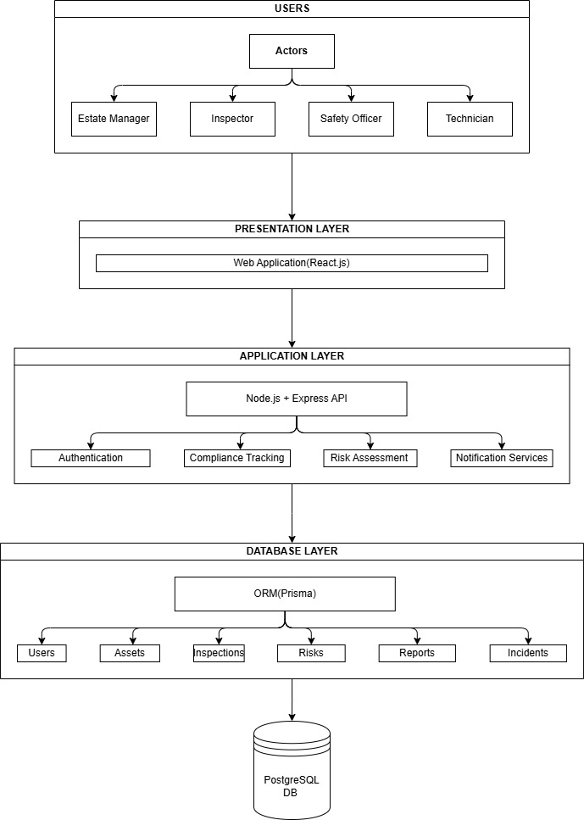

Figure 4.3 System architecture

4.3.2 Entity Relationship Diagram (ERD)
An Entity Relationship Diagram (ERD) is a graphical representation of the entities in a database and the relationships among them. It provides a conceptual view of the database structure by illustrating how data is organized, stored, and linked through primary and foreign keys (Elmasri & Navathe, 2012). The ERD is included in this study to provide a clear representation of the database design for the proposed Facility Compliance and Safety Management System. It helps identify the main entities, their attributes, and relationships, ensuring data consistency, minimizing redundancy, and supporting efficient storage and retrieval of information related to facility assets, inspections, risks, incidents, CAPA tasks, certifications, and users.
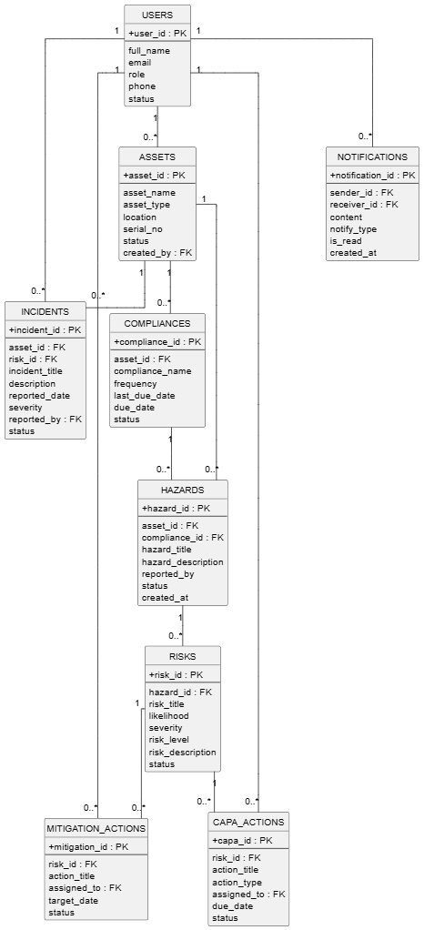
Figure 4.2 ERD diagram

CHAPTER FIVE

IMPLEMENTATION AND TESTING

5.1 Introduction
This chapter presents the implementation and testing of the proposed Facility Compliance and Safety Management System. It describes the technologies and tools used during system development, the implementation of the system modules, and the testing procedures performed to evaluate the system's functionality and performance. The chapter also presents the testing results to verify that the system meets the specified functional and non-functional requirements and operates as intended.

5.2 Implementation
This section describes the implementation of the proposed Facility Compliance and Safety Management System. It explains the major system modules, their functions, and how users interact with them to perform various compliance and safety management activities. Screenshots of the implemented interfaces are provided to illustrate the functionality of each module.

5.2.1 User Authentication Interface
The User Authentication Module provides secure access to the system by allowing authorized users to log in using their registered email and password. After successful authentication, the system verifies the user's role and grants access to the appropriate dashboard based on their responsibilities, such as Administrator, Inspector, Safety Officer, Technician, and Estate Officer. This ensures that users can only access the functions assigned to their respective roles.
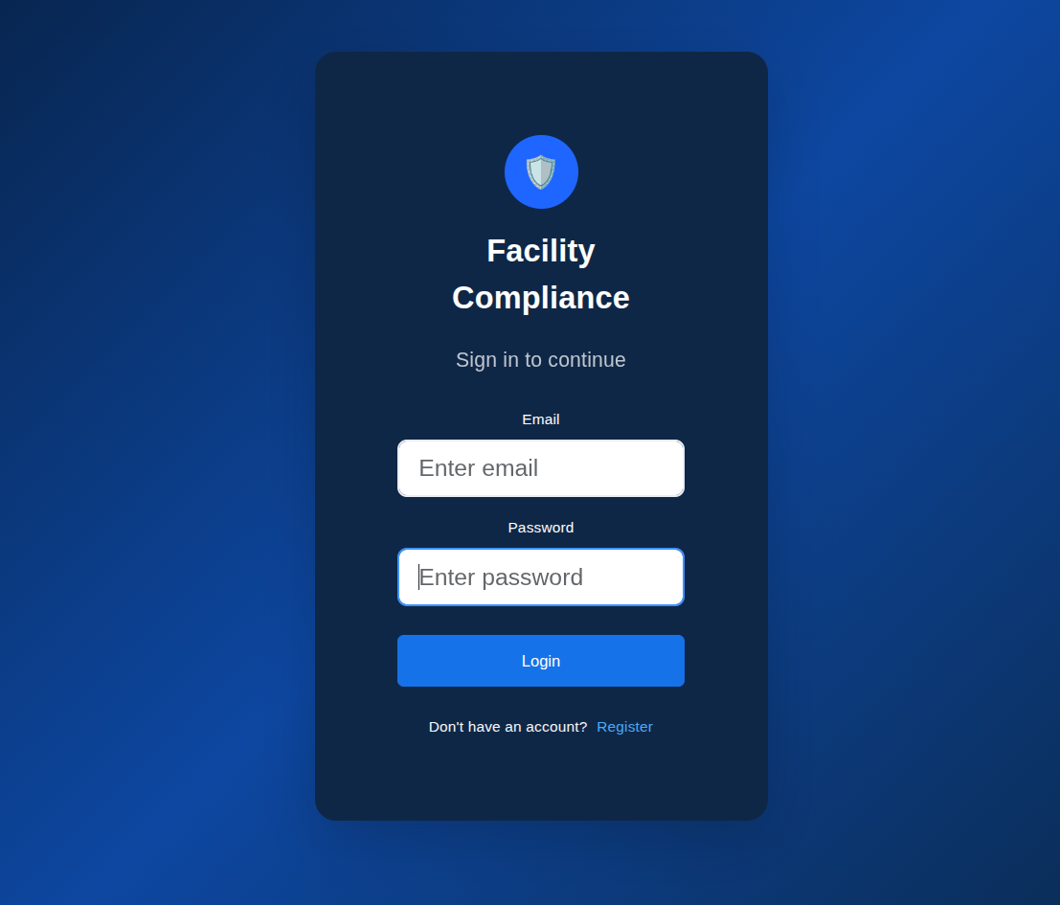
Figure 5.1: Login Page.

5.2.2 Dashboard Interface
The Dashboard Module provides users with an overview of system activities through graphical summaries and statistical information. It displays key information such as the total number of assets, scheduled inspections, compliance status, pending CAPA tasks, reported incidents, and certificates nearing expiry. The dashboard enables users to quickly monitor the overall safety and compliance performance of facility assets.
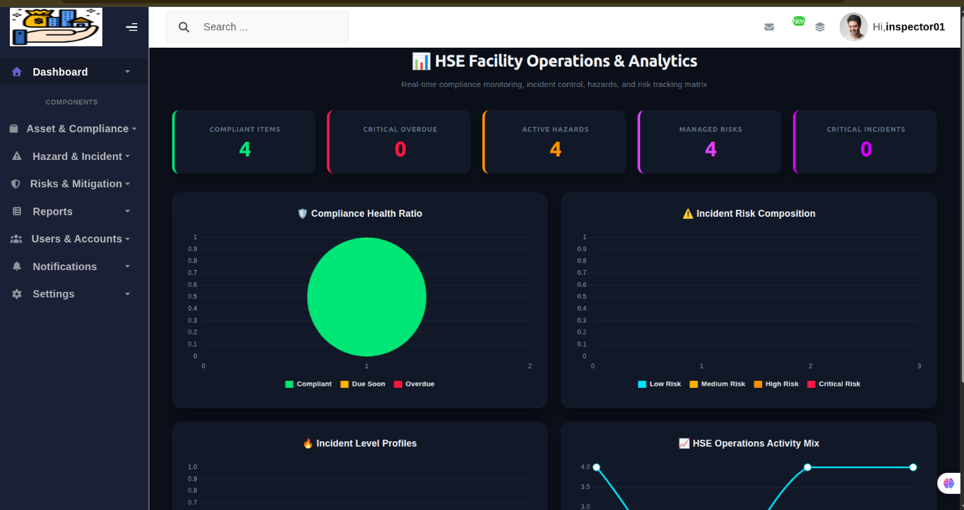
Figure 5.2: Dashboard Interface.

5.2.3 Asset Management Interface
The Asset Management Module enables users to register, update, view, and manage facility assets such as fire protection systems, lifts, electrical installations, boilers, pressure vessels, and environmental permits. Each asset is assigned unique information including its location, category, serial number, and operational status, allowing efficient monitoring throughout its lifecycle.
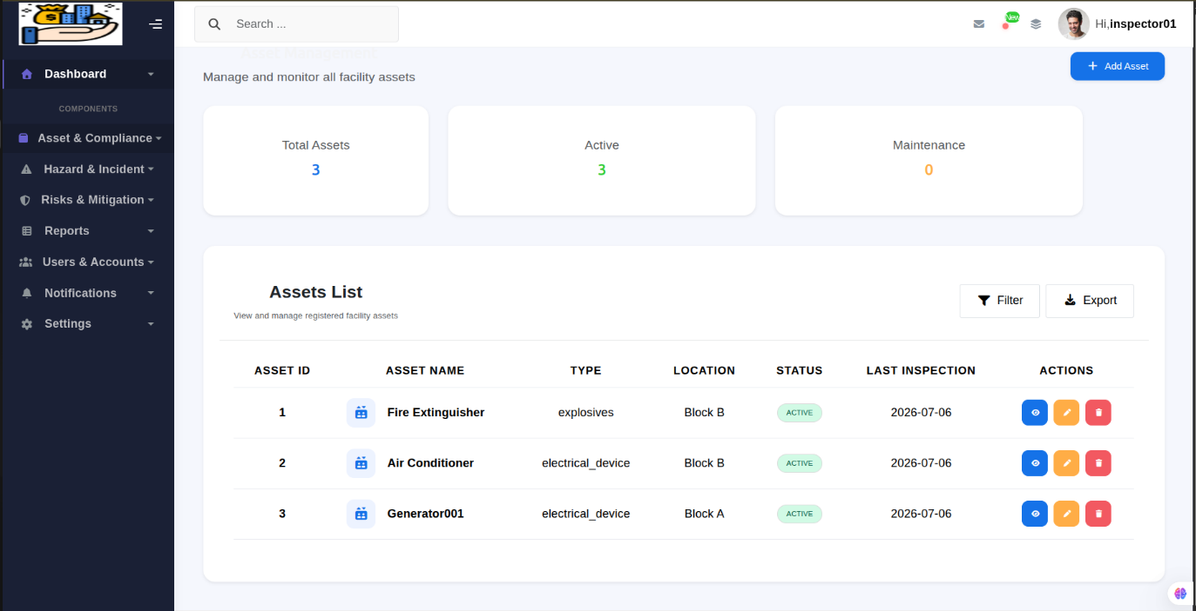
Figure 5.3: Asset Management Interface

5.2.4 Inspection Management Interface

The Inspection Management Module allows inspectors to schedule inspections, record inspection findings, upload inspection reports, and update the compliance status of facility assets. The module maintains inspection history and automatically identifies overdue inspections to support statutory compliance.
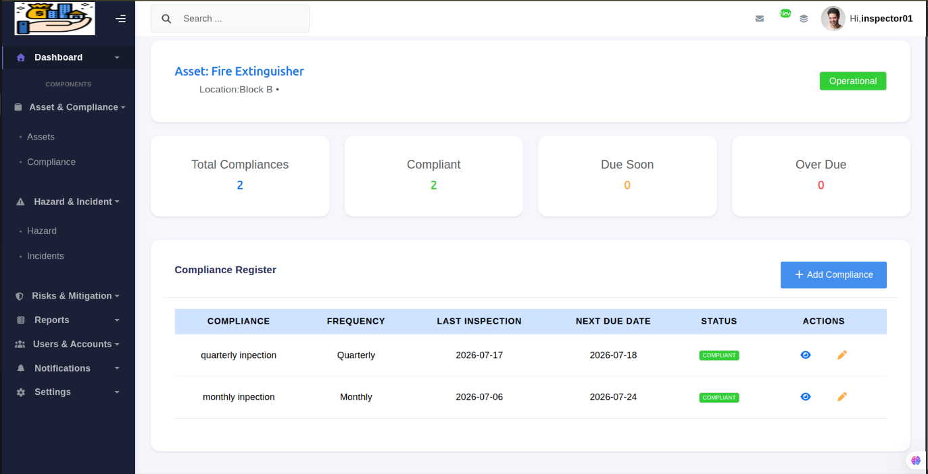
Figure 5.4: Inspection Management Interface.

5.2.5 Compliance Tracking Interface

The Compliance Tracking Module monitors the compliance status of all registered assets by evaluating inspection results, certification validity, and regulatory requirements. Assets are automatically categorized as compliant, non-compliant, pending inspection, or overdue, enabling timely corrective actions.

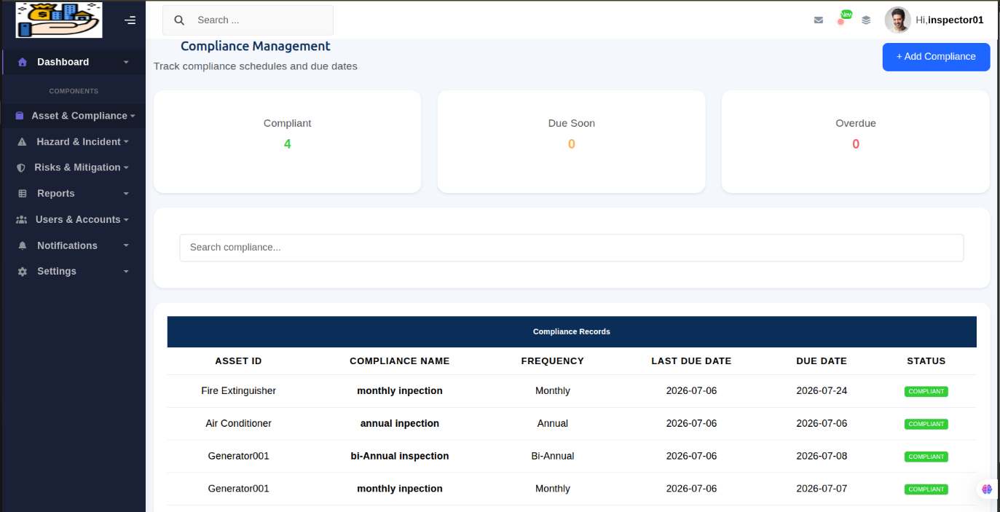
Figure 5.5: Compliance tracking interface

5.2.6 Risk Assessment Interface
The Risk Assessment Module enables Safety Officers to identify hazards, assess risk levels, assign mitigation measures, and maintain a comprehensive risk register. Risks are categorized according to their likelihood and severity to assist in prioritizing safety interventions.
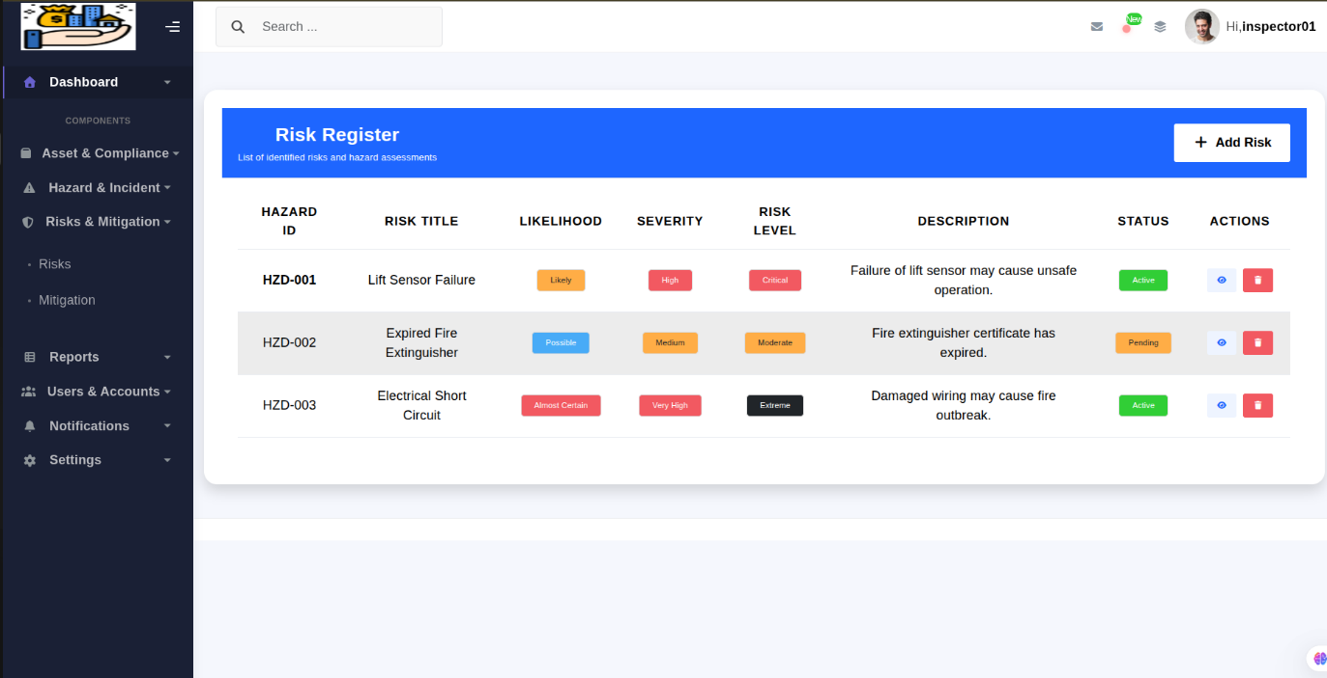
Figure 5.6: Risk Assessment Interface.

5.2.7 Incident Management Interface
The Incident Management Module allows users to report incidents and near-miss events associated with facility assets. The system records incident details, affected assets, severity level, supporting evidence, and investigation results, facilitating effective incident management and future analysis.
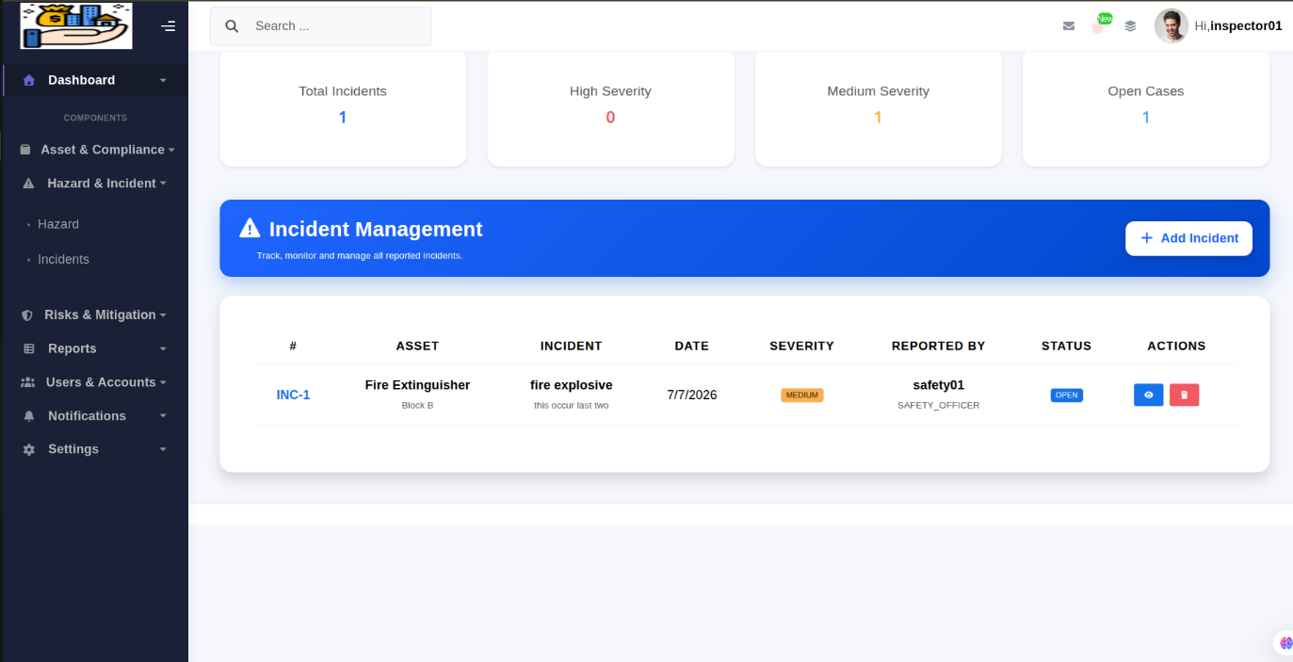
Figure 5.7: Incident Management Interface.

5.2.8 CAPA Management Interface
The Corrective and Preventive Action (CAPA) Management Module enables Safety Officers to create corrective and preventive action tasks after risks, incidents, or inspection findings are identified. CAPA tasks are assigned to technicians, monitored until completion, and verified before the asset's compliance status is updated.
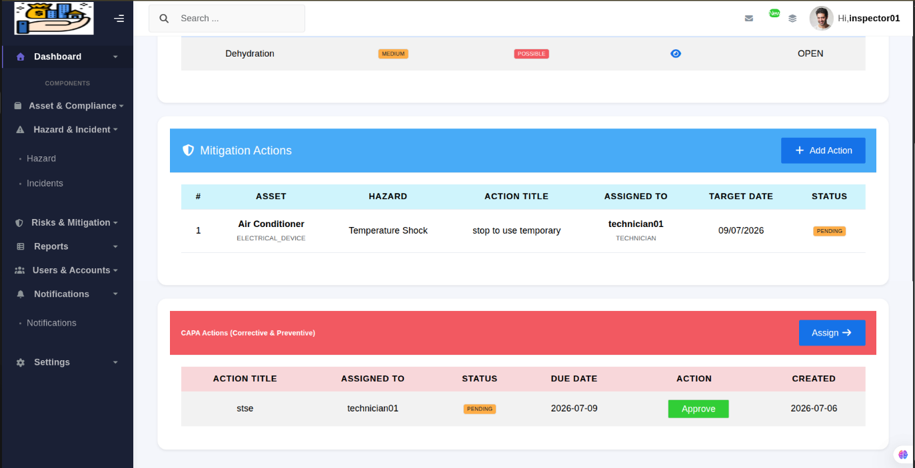
Figure 5.8: CAPA Management Interface.

5.2.9 Reports Interface
The Reports Module generates comprehensive reports on inspections, compliance status, incidents, risk assessments, CAPA activities, and certification records. These reports assist management in monitoring system performance, supporting audits, and making informed decisions regarding facility safety.
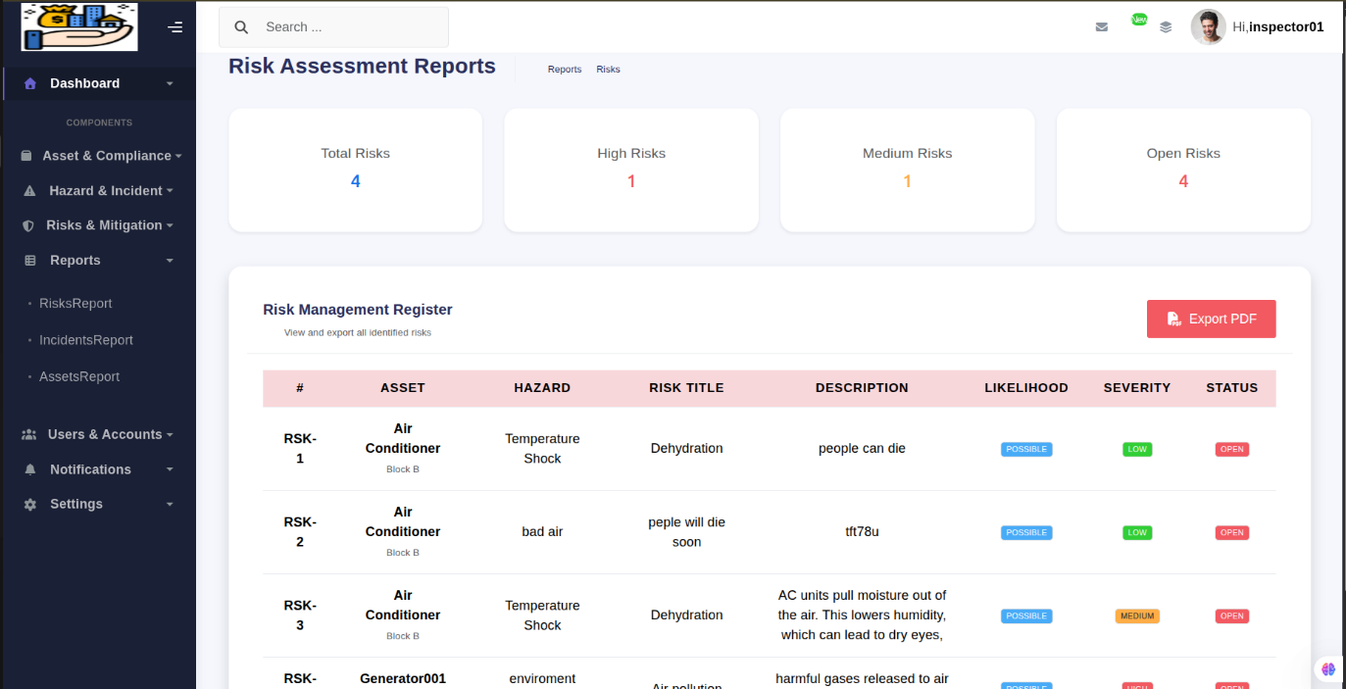
Figure 5.9: Reports Interface.

5.3 Testing
Testing is the process of evaluating a software system to determine whether it meets the specified requirements and functions correctly under different conditions. According to Sommerville (2016), software testing is performed to identify defects, verify that system components operate as expected, and ensure the overall quality and reliability of the software. In this study, Unit Testing, Integration Testing, System Testing, and Black-box Testing were conducted to verify the functionality, integration, performance, and correctness of the proposed Facility Compliance and Safety Management System. These testing methods were selected because they ensure that individual modules, integrated components, and the complete system function correctly while satisfying the specified functional requirements.

5.3.1 Unit Testing

Unit testing is a software testing technique in which individual components or modules are tested independently to verify that each unit performs its intended function correctly (Pressman & Maxim, 2020). In this study, unit testing was performed on individual modules such as user authentication, asset management, inspection management, risk assessment, incident reporting, CAPA management, certification management, and notification services. The objective was to ensure that each module functioned correctly before integrating it with other system components.

5.3.2 Integration Testing

Integration testing is the process of testing the interaction between multiple software modules to ensure they communicate and exchange data correctly (Sommerville, 2016)). This testing was conducted after successful unit testing to verify that modules such as inspection management, compliance tracking, CAPA management, and certification management worked together without errors. The test confirmed that data generated in one module was correctly shared and processed by related modules.

5.3.3 System Testing
System testing evaluates the complete and integrated software system to verify that it satisfies all specified functional and non-functional requirements (Pressman & Maxim, 2020). In this study, the entire Facility Compliance and Safety Management System was tested to ensure that all modules operated correctly as a unified system. The testing verified user authentication, asset management, inspections, risk assessment, incident management, CAPA workflows, compliance tracking, and reporting functionalities.

5.3.4 Black-box Testing

Black-box testing is a software testing method that evaluates the functionality of a system without considering its internal code or implementation (Sommerville, 2016) The tester provides valid and invalid inputs and verifies whether the outputs match the expected results. This testing method was used because the primary objective of the study was to verify that the implemented system met the specified user requirements and performed all expected functions correctly.

5.3.5 Functional Testing
Functional testing was conducted to verify that each functional requirement of the proposed system produced the expected output. Table 5.1 presents the functional requirements, expected outcomes, and actual test results.
Table 5.1: Functional Testing Results
S/N | Functional Requirement | Expected Outcome | Test Result
1 | User login | Authorized users successfully log into the system. | Passed
2 | User management | Administrator can add, update, and deactivate users. | Passed
3 | Asset registration | Users can register and update facility assets. | Passed
4 | Compliance tracking | System correctly updates asset compliance status. | Passed
5 | Risk assessment | Safety Officer records and assesses risks successfully. | Passed
6 | Incident reporting | Users successfully report incidents and near-miss events. | Passed

CHAPTER SIX

RESULTS AND DISCUSSION

6.1 Introduction
This chapter presents and discusses the results obtained from the implementation and testing of the proposed Facility Compliance and Safety Management System. It evaluates the extent to which the developed system achieved the research objectives and fulfilled the identified user and system requirements. The chapter also discusses the effectiveness of the implemented modules in improving facility safety management, statutory compliance tracking, risk assessment, incident management, and CAPA tracking

6.2 Findings
Identifying and Collecting User Requirements for the Integrated Compliance Tracking and Risk Management System for Facility Safety:
The results indicated that facility management staff members faced certain issues in using the current manual system of compliance management. Using interviews, it was found out that there were problems in tracking statutory inspections, monitoring expiration dates for certificates, asset-based risk management, incident management, and carrying out CAPA management. It was necessary to create a digital tool that would help in providing automated alerts, inspection schedule management, compliance status tracking, documentation management, and access control by roles.

Designing the web based Integrated Compliance Tracking and Risk Management System for Facility Safety:
It can be observed that the design of the system was able to fulfill the requirements of the users by providing an integrated architecture which includes web applications along with a centralized database. Some of the modules which were incorporated in the system include user management, asset management, compliance tracking, inspection management, risk assessment, incident reporting, CAPA management, certification management, notifications, and reports. In addition to this, UML diagrams, entity relationship diagram, and system architecture were used to show the structure of the system.

For the developing of the web based Integrated Compliance Tracking and Risk Management System for Facility Safety:
The results demonstrate that the developed system has been created through the use of React.js for the web application, Node.js and Express.js for backend services, and PostgreSQL for the database management system. The developed system allows for management of the facility assets, scheduling and logging inspections, tracking the compliance status, risk identification and assessment, reporting on any incidents, managing CAPA tasks, certification documentation storage, and getting automated notifications about pending inspections and certification expiration dates.
For Testing and evaluation of the web based Integrated Compliance Tracking and Risk Management System for Facility Safety:
The results obtained from the system evaluation have shown that the proposed system meets the required criteria in terms of user and system needs. This system has been evaluated using unit testing, integration testing, system testing, and black box testing, and all functional components have worked as per expectations. The results have shown that the system provides effective management of compliance records, inspection scheduling, risk management and incident management, management of CAPA, and overdue and certification notification systems.

6.2.1 Product
The product obtained at the end of this study is an Integrated Compliance Tracking and Risk Management System for Facility Safety, developed to improve the management of statutory inspections, compliance monitoring, and facility safety activities. The system consists of a web application that enables users to perform inspections, report incidents, manage assigned CAPA tasks
The developed system integrates several functional modules, including user management, asset management, compliance tracking, inspection scheduling, risk assessment, incident management, corrective and preventive action (CAPA) management, certification management, notification services, and reporting. The system automatically tracks inspection schedules and certification expiry dates, updates compliance status, generates notifications for upcoming or overdue inspections, maintains asset-based risk registers, and stores inspection reports and statutory certificates in a centralized database.

6.3 Goal Achieved
The study successfully achieved its overall goal of developing an Integrated Compliance Tracking and Risk Management System for Facility Safety that supports effective compliance monitoring, risk management, and statutory inspection management. The achievement of this goal is demonstrated through the successful accomplishment of the four specific objectives.
The first objective, which was to identify and gather user requirements, was achieved through interviews with facility management personnel. The findings identified key user requirements, including asset management, inspection scheduling, compliance tracking, risk assessment, incident reporting, CAPA management, certification management, document management, automated notifications, and role-based access control. These requirements formed the basis for the system design and development.
The second objective, which was to design the proposed system, was achieved by developing the system architecture, Entity Relationship Diagram (ERD), Unified Modeling Language (UML) diagrams, database design, and system workflows. These design models provided a clear blueprint for implementing an integrated compliance and risk management solution.
The third objective, which was to develop the proposed system, was successfully accomplished by implementing both web applications integrated with a centralized PostgreSQL database. The developed system supports asset registration, compliance tracking, inspection scheduling, risk assessment, incident management, CAPA tracking, certification management, document storage, reporting, and automated notifications.
Finally, the fourth objective, which was to evaluate the proposed system, was achieved through unit testing, integration testing, system testing, and black-box testing. The evaluation results showed that all functional modules operated correctly and produced the expected outcomes. The findings demonstrate that the developed system effectively addresses the limitations of manual compliance management and provides an efficient, reliable, and centralized solution for improving facility safety and regulatory compliance.

6.4 Challenges and Limitations
During the development of the web based Integrated Compliance Tracking and Risk Management System for Facility Safety, several challenges were encountered. One of the major challenges was collecting comprehensive user requirements from different stakeholders, as each user role had unique responsibilities and expectations regarding compliance and safety management. Another challenge was integrating multiple functional modules, such as compliance tracking, inspection scheduling, risk assessment, incident management, CAPA tracking, and certification management, into a single centralized system while ensuring consistency and efficient data flow. Additionally, designing automated notification mechanisms and compliance status calculations based on inspection schedules and certification expiry dates required careful implementation and testing.
The study was also subject to certain limitations. The developed system was evaluated within a limited environment using selected users and facility assets, and therefore its performance in large-scale organizations with numerous facilities and assets was not assessed. Furthermore, the system currently focuses on facility compliance and safety management and does not incorporate advanced technologies such as Internet of Things (IoT) sensors for real-time asset monitoring or artificial intelligence techniques for predictive risk analysis. These limitations provide opportunities for future enhancements and further research.

CHAPTER SEVEN

CONCLUSION AND RECOMMENDATIONS

7.1 Introduction
This chapter presents the conclusion and recommendations of the study. It summarizes the major findings of the research, shown the extent to which the research objectives were achieved, and discusses the overall contribution of the developed web based Integrated Compliance Tracking and Risk Management System for Facility Safety. The chapter also provides recommendations for future improvements and further research to enhance the system's functionality and applicability in different organizational environments.

7.2 Conclusion

7.2.1 Conclusion for identification and gather user requirement
The first objective, which aimed to identify and gather user requirements for the Integrated Compliance Tracking and Risk Management System for Facility Safety, was successfully achieved. The study identified the functional and non-functional requirements through interviews with facility management personnel. The findings revealed the need for a centralized system capable of managing facility assets, tracking statutory inspections, monitoring compliance status, assessing risks, reporting incidents, managing CAPA activities, storing certification documents, and providing automated notifications. These requirements provided a solid foundation for the design and development of the proposed system.

7.2.2 Conclusion for designing
The second objective, which aimed to design the Integrated Compliance Tracking and Risk Management System for Facility Safety, was successfully accomplished. The system architecture, Entity Relationship Diagram (ERD), UML diagrams, and database design were developed to provide a structured framework for implementing the proposed solution. The design addressed the limitations identified in previous studies by integrating compliance tracking, inspection scheduling, risk management, incident reporting, CAPA tracking, and certification management into a single platform. Consequently, the proposed design provides a comprehensive and scalable solution for improving facility safety management.

7.2.3 Conclusion for implementation
The third objective, which aimed to develop the Integrated Compliance Tracking and Risk Management System for Facility Safety, was successfully achieved. The study resulted in a fully functional web-based system developed using modern technologies. The implemented system provides modules for user management, asset management, compliance tracking, inspection scheduling, risk assessment, incident reporting, CAPA management, certification management, document management, notifications, and reporting. By integrating these functionalities into one centralized platform, the developed system addresses the gaps identified in previous studies regarding digital compliance monitoring, automated alerts, structured CAPA workflows, and asset-based risk management.

7.2.4 Conclusion for Testing and validation

The fourth objective, which aimed to evaluate the web based Integrated Compliance Tracking and Risk Management System for Facility Safety, was successfully accomplished. The evaluation results demonstrated that the system satisfied the specified functional and non-functional requirements through unit testing, integration testing, system testing, and black-box testing. All major modules operated correctly and produced the expected results. The evaluation confirmed that the developed system improves compliance monitoring, enhances facility safety management, supports timely inspection scheduling, and provides an efficient digital solution for managing statutory inspections and regulatory compliance.

7.3 Recommendations
b inspections and certification expiries, and support timely decision-making through automated notifications and centralized reporting.
For future studies, researchers are encouraged to enhance the system by integrating advanced technologies such as the Internet of Things (IoT) for real-time monitoring of facility assets, artificial intelligence (AI) for predictive risk analysis and maintenance, and Geographic Information Systems (GIS) for asset location visualization. Future research may also evaluate the system in larger organizations with multiple facilities and integrate additional regulatory standards to further improve its applicability and scalability.

7.3 Recommendations

Based on the findings of this study, it is recommended that organizations adopt the developed Integrated Compliance Tracking and Risk Management System for Facility Safety to replace manual compliance management approaches. The system should be deployed and customized according to organizational requirements to improve statutory inspection tracking, certification monitoring, risk management, incident reporting, and corrective action follow-up. Regular user training should also be provided to ensure that facility managers, inspectors, safety officers, and technicians can effectively utilize the system.
For future improvements, it is recommended that the system be enhanced by integrating advanced technologies such as Internet of Things (IoT) sensors for real-time monitoring of facility assets, artificial intelligence for predictive risk analysis, and mobile location-based services for improving inspection efficiency. Future researchers may also consider evaluating the system in larger organizations with multiple facilities to measure scalability, performance, and long-term impact on safety compliance management.

7.4 Further Study
Although this study successfully developed an Integrated Compliance Tracking and Risk Management System for Facility Safety, some gaps remain for future research. The current system mainly depends on user-entered data and scheduled inspections, without direct integration with physical asset monitoring devices. Further studies should investigate the integration of IoT-based sensors, machine learning techniques, and predictive analytics to enable real-time hazard detection, automatic failure prediction, and proactive maintenance planning. Additionally, future research may explore integration with external regulatory databases and automated compliance standards verification to further improve regulatory compliance and decision making in complex facility environments.

REFERENCES
Amer, S., Rashed, J., Elayan, W., Almazrouei, K., & Alshabibi, A. (n.d.). Managing Electrical Fire Risks in Substations: A Framework to Protect Lives and Assets.
Barbosa, A. de S., Bueno da Silva, L., de Souza, V. F., & Morioka, S. N. (2022). Integrated Management Systems: their organizational impacts. Total Quality Management & Business Excellence, 33(7–8), 794–817. https://doi.org/10.1080/14783363.2021.1893685
Bass, L., Clements, P., & Kazman, R. (n.d.). Software architecture in practice (3rd ed.). Addison-Wesley.
Chu, C. (2017). WATER-ENERGY NEXUS IN CHINA AND ITS IMPLICATIONS FOR REGIONAL WATER AND ENERGY SELF-SUFFICIENCY.
Elmasri, R., & Navathe, S. B. (n.d.). Fundamentals of database systems (7th ed.). Pearson.
I.E.E.E. (n.d.). IEEE recommended practice for software requirements specifications. IEEE Computer Society.
Marchetti, S., Di Maio, F., & Zio, E. (2026). An Integrated Deterministic and Probabilistic Safety Assessment of Multi-Unit Small Modular Reactors Considering the Degradation of Shared Safety Features. Nuclear Science and Engineering, 200(6), 1323–1339. https://doi.org/10.1080/00295639.2025.2515349
Marchetti-Mercer, M. C. (2012). Those Easily Forgotten: The Impact of Emigration on Those Left Behind. Family Process, 51(3), 376–390. https://doi.org/10.1111/J.1545-5300.2012.01407.X
Peter Dey, P., Khan, M., Amin, M., Raj Sinha, B., & Badkoobehi, H. (2016). Software Project Management Challenges. International Review of Research in Emerging Markets and the Global Economy (IRREM) An Online International Research Journal, 2, 1. www.globalbizresearch.org
Pressman, R. S., & Maxim, B. R. (n.d.). Software engineering: A practitioner’s approach (9th ed.). McGraw-Hill Education.
Ramos, T. B., Caeiro, S., & Hoof, B. (n.d.). Environmental and safety compliance management systems: Governance, auditing, and regulatory compliance.
Salaheldin, M. H., Hassanain, M. A., Hamida, M. B., & Ibrahim, A. M. (2021). A code-compliance assessment tool for fire prevention measures in educational facilities. International Journal of Emergency Services, 10(3), 412–426. https://doi.org/10.1108/IJES-06-2020-0030
Shabani, T., Jerie, S., & Shabani, T. (2024). A comprehensive review of safety audits: ensuring workplace safety and compliance in Zimbabwe. Safety and Reliability, 43(2), 86–113. https://doi.org/10.1080/09617353.2024.2343958
Shaw, D., Abad, R., Amin-Chowdhury, Z., Bautista, A., Bennett, D., Broughton, K., Cao, B., Casanova, C., Choi, E. H., Chu, Y. W., Claus, H., Coelho, J., Corcoran, M., Cottrell, S., Cunney, R., Cuypers, L., Dalby, T., Davies, H., de Gouveia, L., … Brueggemann, A. B. (2023). Trends in invasive bacterial diseases during the first 2 years of the COVID-19 pandemic: analyses of prospective surveillance data from 30 countries and territories in the IRIS Consortium. The Lancet Digital Health, 5(9), e582–e593. https://doi.org/10.1016/S2589-7500(23)00108-5
Shelly, G. B., & Rosenblatt, H. J. (n.d.). Systems analysis and design (9th ed.). Cengage Learning.
Shrivastava, A., & Tripathi, S. P. (2011). A Requirements Engineering Maturity Measurement Framework Tool for Medium and Small Scale Software Companies. International Review on Computers & Software, 6(5), 725.
Sommerville, I. (n.d.-a). Software engineering (10th ed.). Pearson.
Sommerville, I. (n.d.-b). Software engineering (9th ed.). Addison-Wesley.

APPENDIX
Table: Summary of Interview Responses
Interview Question | Summary of Respondents' Responses
1. What is your current role in facility management? | Respondents included Estate Managers, Inspectors, Safety Officers, and Technicians.
2. What types of facility assets do you manage or inspect? | Fire extinguishers, lifts, generators, boilers, electrical systems, air conditioners, pressure vessels, and fire alarm systems.
3. What challenges do you face in managing facility inspections manually? | Respondents reported difficulties in tracking inspection schedules, misplaced records, delayed inspections, and missed compliance deadlines.
4. How do you currently track compliance and certification expiry dates? | Most respondents use paper files, spreadsheets, diaries, or manual reminders, making tracking inefficient.
6. What happens when an inspection is missed or overdue? | Delays in inspections may lead to expired certificates, increased safety risks, and non-compliance with regulations.
7. Do you use any digital tools? | Most respondents indicated that they rely mainly on manual methods, with limited use of spreadsheets.
8. How do you identify and record risks? | Risks are identified during inspections and recorded in notebooks or paper reports.
9. Do you maintain a risk register? | Some respondents maintain manual risk registers, while others do not have a structured risk management process.
10. How are high-risk issues prioritized? | High-risk issues are reported to supervisors for immediate attention, but prioritization is mostly manual.
12. Do you receive automatic alerts? | No. Respondents indicated that automatic notifications are not available.
14. What features would you like in a digital system? | Asset management, inspection scheduling, compliance tracking, incident reporting, CAPA management, document storage, reporting, dashboards, and automated notifications.
15. How useful would real-time monitoring be? | Respondents indicated that it would improve decision-making, reduce response time, and enhance safety management.

